Chronology of Instrument Designs and Ideas

Sep-2016:

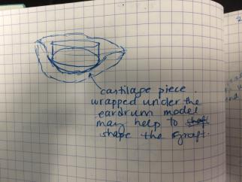

Problem: too much time to shape the cartilage graft in the appropriate shape. Solution: Cartilage 3D stencil to help shape the ear drum graft. A variant of this was tried before, and it took too long to print (too much time used) and the end result wasn’t perfect. Dr. James printed a 2D outline of the ear drum in that case.

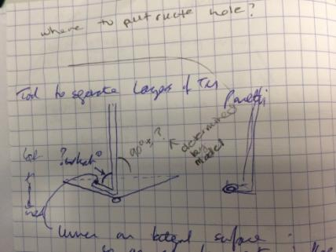

Problem: left and right Panetti suckers are not perfect – the bend angle is 90deg.

* 90deg not optimal for ear drum which is not perfectly flat
* What is the optimal bending angle for the Panetti sucker?

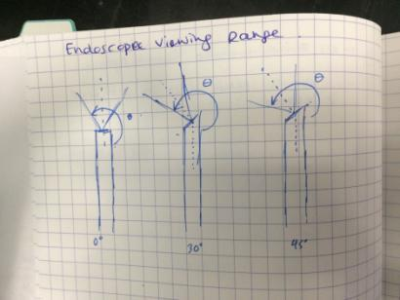

Problem: cannot reach the areas visualized by the endoscope. Need a tool that can bend around the endoscope to reach something.

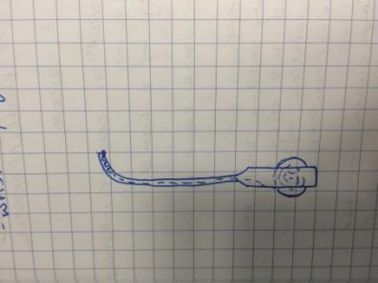

Can use a wrist or concentric tubes to reach into the viewing field of the endoscope. Problem: need to feed instrument in straight, alongside endoscope and then bend (could be done by an instrument with a permanent bend in the middle or a bendable tip e.g. concentric tubes or wrist)

Handle is actuated via dial for the thumb

Question: what is the tip doing? 🡪 Workspace analysis

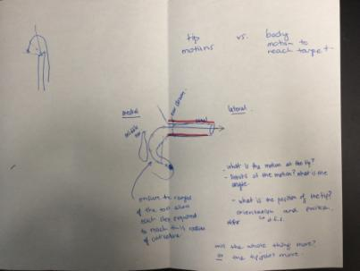

Workspace Analysis:

1. Tip Design

* Measure the orientation space using electromagnetic electrodes at the tip of a printed Rosen
* Measures the orientation of the tip while dissecting
* 3D print ear model for this

1. Body Design

* 3D printed ear model with orientation space and endoscope added to it
* Add a stick and play around with the geometries to figure out appropriate body angles/bends/curves to access certain regions – antrum and sinus tympani

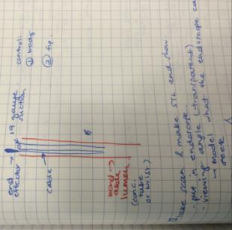

End effecter actuated via wires (e.g. forceps or curette) and suction down the lumen – like the Grace medical instruments but cut the tip of the lumen so the end effecter and suction are more closely integrated -> complicated handle design is not ideal for surgeons as they will have to learn how to use it -> make it easy and intuitive/native to the way that their current instruments work

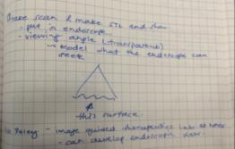

Make a surface STL that shows the direct view of the endoscope

Spoke with Harley (Mike Daley’s colleague) about this and he can make it as long as we provide a CT image with at least 0.5mm resolution, isotropic

If we publish using his contribution, we add him as co-author (that is his payment)

Oct-2016

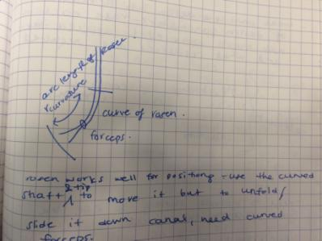

Curve forceps into Rosen needle bend to help facilitate graft movement

Graft introduction uses the forceps to place it into the ear canal first and then the rosen needle is used to slide it down the canal and position it

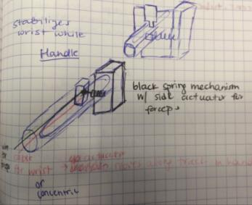

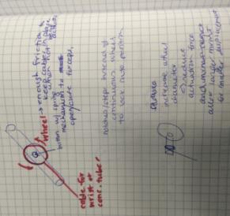

* Slider or dial mechanism to actuate concentric tubes and forceps
* Decoupled forceps and concentric tubes: use dial + button in the middle (probably only allows either open or closed, not in the middle)
  + Dial + slider underneath
* Coupled forceps and concentric tubes: use slider with button to actuate forceps (more control, able to half open forceps)
* Need to lock the dial in place – notches in the dial that locks the tubes in place
* Also want stiff tubes (as per feedback from EES course 19-Oct-2016) therefore lock would help that, and selecting the material, thickness
* Dial -> can calibrate the force vs. displacement -> wrap cable around thin axle attached to large dial -> large dial displacement = small cable displacement
* Use friction pads to ensure the dial doesn’t move to easily
* After the course – it seems that for greater adoption of tools, a very simple tool (without moving parts) would be more widely accepted
* The concentric tubes introduces the risk of how to retract the instrument quickly without having to think too much about how it got there – therefore, workspace study will be useful to figure out the appropriate geometry to permanently bend a sucker and its tip to access the necessary regions.

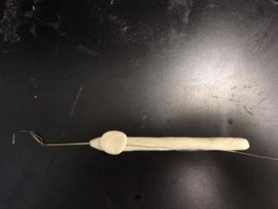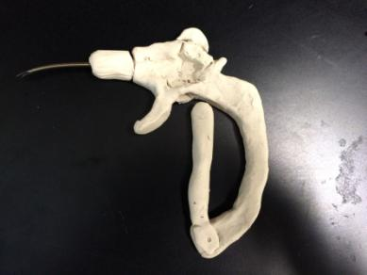

* Internal regulatory required for instrument use and publication needs REB
* Easier to get regulatory if the instrument is similar to existing (shape, function and material)
* If using the flexible wrist or concentric tubes, will be more complicated process to get approval to use in the patient

Nov-2016:

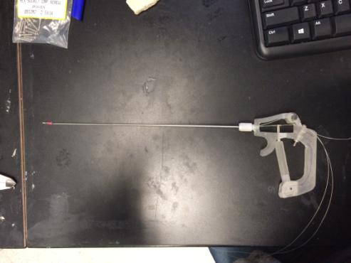

* First pass prototype
* Wheel was too small to actuate the wrist -> too much force required and not enough grip on the wheel to actuate wrist -> added protrusions so the thumb can use those to move the wheel
* Arm was too flimsy to actuate grippers
* Handle body didn’t fit in hand naturally -> changed shape so sits better in the palm

Prototype v-2:

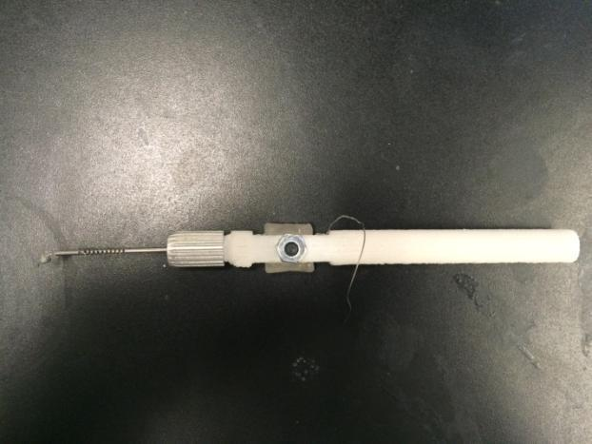

* Make the wheel larger and have more purchase for your finger
* Handle is a bit thicker than other instruments
* Integrating suction: got sheaths from needles (spinal tap needle) to use to cover the cuts/notches if using tool for suction
* Integrate a button to open/close forceps?
* Rosen needle curvature should be covered by the range of curvature of the tip

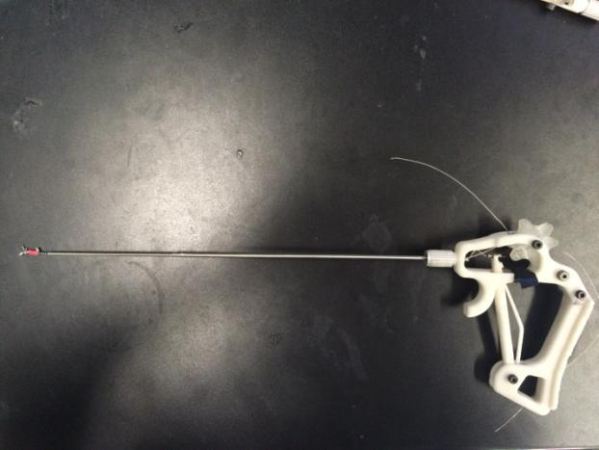

* Make the handle bigger to fit in palm
* Make the wheel have more protrusions (like a gear) for better purchase
* Angle the shaft so that the axis of rotation is the shaft -> ensure the shaft does not make an arc when the tool is being rotated

Dec-2016:

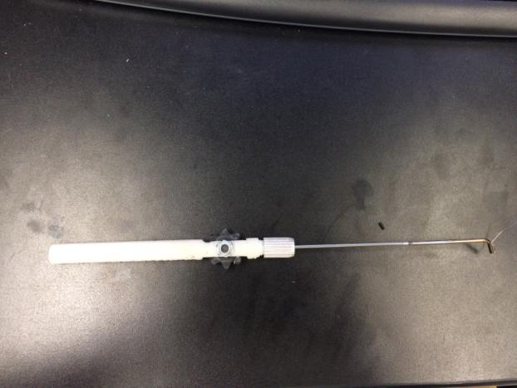

* Liked the wheel this time because of the gear
* Easy to actuate the tip bending
* Want the tip to be stiffer (will use optimal mechanical closure design for tip)
* Want to fit a lumen of 19gauge size inside for suction
* Could be feasible for E, N and T surgeries
* Run suction tube along the body of the tool

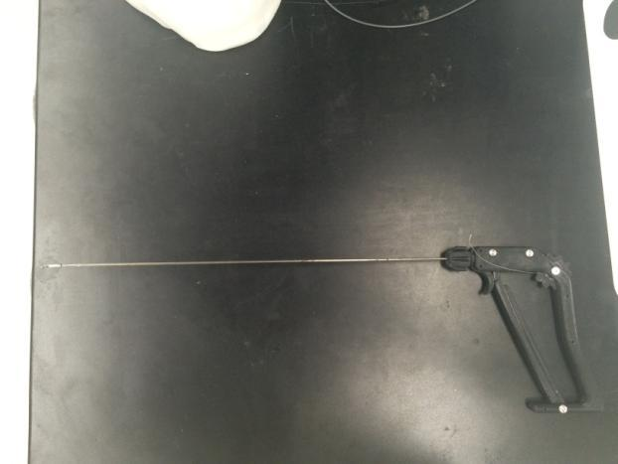

* For POP presentation
* Includes new tip cutting pattern for mechanical closure and stiffness
* Roll
* Forceps
* Wrist
* Form 1 printer for small parts
* Makerbot for larger parts

Wheel design:

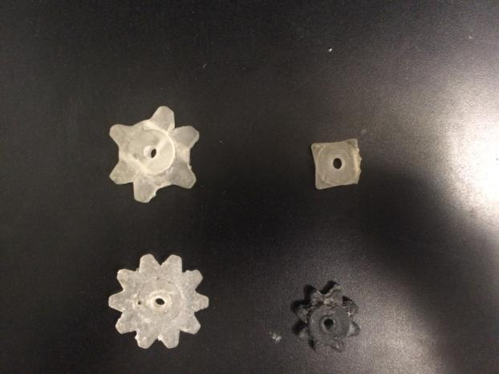

**4**

**3**

**2**

**1**

1: From Peter’s project, inserted the finger ridges onto it -> Too clunky, too many parts required as there are two halves that are joined together by two screws

2: not enough purchase for fingers, but thinner so easier to assemble

3: Too big, not enough purchase for fingers, hole to insert cable is not always printed and not a reliable print  
  
4: Small enough for the pen ent tool, good purchase for fingers – positive reception by Dr. James, but same problems with the hole   
  
Need to check if the wheel would interfere with the endoscope alongside it

24-Jan-2017:

**Instrument Design Decisions:**

**Tip:**

Material: Nitinol that will be cut into notches to allow the tip to bend

Cable – (get the details of the cable material and composition, why this specific cable is used to articulate the bending of the tip? – why do other instruments in the lab use it?)

**Geometry:**

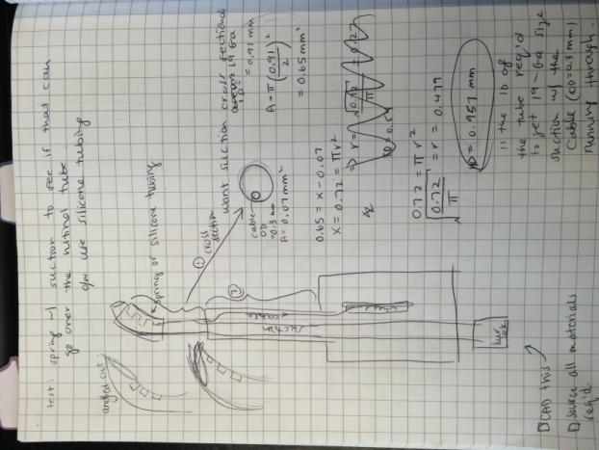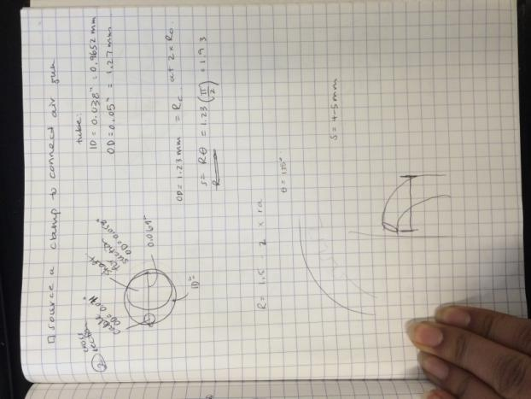

For suction that is desirable for TEES surgery in Dr. James’ OR: use 19 Gauge ID = 0.91mm

Cable OD = 0.3mm

Atube = Acable + A19gauge

= pi*0.15^2 + pi*0.455^2

= 0.721mm^2

* 0.721mm^2 = Atube = pi*rtube^2

Rtube = root(0.72/pi) = 0.479 mm

IDtube = 0.958mm at least to achieve the same cross sectional area as a 19 gauge sucker, as this tip has a cable of OD 0.3mm running through it, subtracting from the sucking cross sectional area.

Found a tube in the lab with the following dimensions:

ID = 0.0405” = 1.0287 mm

OD = 0.049” = 1.2446 mm

Sucking cross sectional area = pi*0.51435^2 = 0.83 mm^2 which is larger than the minimum cross sectional diameter required for this dimensional constraint.

**Tip Bending Angle:**

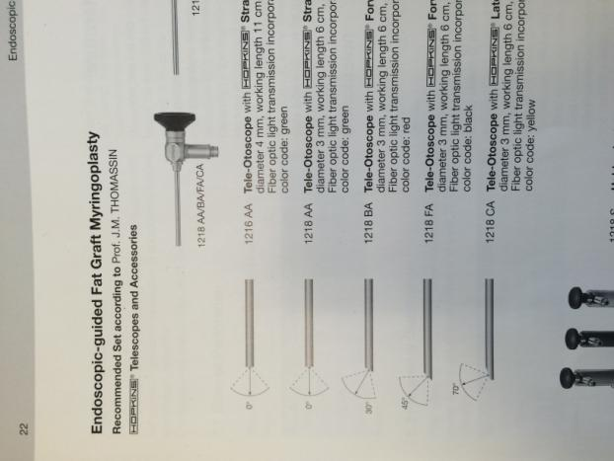from catalogue: “Endoscopic-Guided Fat Graft Myringoplasty – Technique, Equipment and Indications” page 22

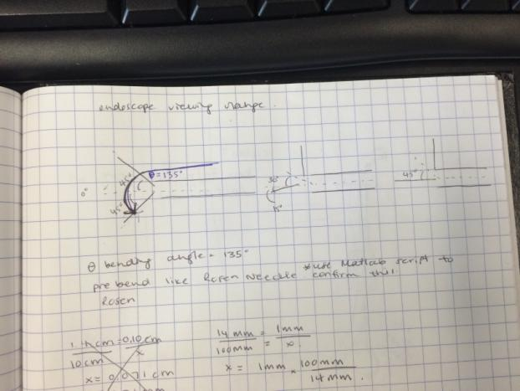

From the endoscope catalogue – for the 0 deg. Endoscope, the tool tip would have to bend the most to get to the viewing angle boundary (135 deg. = 3pi/4) vector pointing horizontal to vector pointing orthogonal to a line which is 45 deg from horizontal

From Kyle’s ASME paper, Rc = 2*Ro

Rc = 1.2446 mm

S = Rc* theta (bending angle)

= 1.2446*3Pi/4 = 2.93mm

From ANSYS simulation of Kyle’s cut geometry from that paper, a single notch with the ID, OD of this tube, will bend ~ 40deg. So if you have 3 cuts, 0.75 mm spaced out

Used solidworks to update the notch geometry to make each notch bend more so 135 deg could be reached.